

**Savitribai** **Phule** **Pune** **University**

**Modern** **Education** **Society’s** **College** **of** **Engineering,** **Pune**

19, Bund Garden, V.K. Joag Path, Pune – 411001.

**ACCREDITED** **BY** **NAAC** **WITH** **“A”** **GRADE** **(CGPA** **–** **3.13)**

**DEPARTMENT** **OF** **COMPUTER** **ENGINEERING**

**A**

**MINI** **PROJECT** **REPORT**

ON

***“Software Dev Mini Project Title Here”***

**T.E.** **(COMPUTER)**

*SUBMITTED* *BY*

**Mr. XXXXXXXXXXXXX Roll No:- xx**

**Ms. XXXXXXXXXXXXX Roll No:- xx**

**Mr. XXXXXXXXXXXXX Roll No:- xx**

**Ms. XXXXXXXXXXXXX Roll No:- xx**

*GUIDED* *BY*

**Prof.** **X. X. XXXXXXX**

**(Academic** **Year:** **2020-2021)**



**Modern** **Education** **Society’s** **College** **of** **Engineering,** **Pune** 19, Bund Garden, V.K. Joag Path, Pune – 411001.

**ACCREDITED** **BY** **NAAC** **WITH** **“A”** **GRADE** **(CGPA** **–** **3.13)**

**DEPARTMENT** **OF** **COMPUTER** **ENGINEERING**

*CERTIFICATE*

*This* *is* *to* *certify* *that*

Mr. XXXXXXXXXXXXXX (Roll No. xx)

Mr. XXXXXXXXXXXXX (Roll No. xx)

Mr. XXXXXXXXXXXXX (Roll No. xx)

Mr. XXXXXXXXXXX (Roll No. xx)

*has* *been* *completed* *Mini* *Project* *entitled*

*“PROJECT TITLE HERE (SDL) 2020-21”*

*As* *a* *partial* *fulfillment* *of* *the* *Third* *Year* *of* *Bachelor* *degree* *in* *“Computer* *Engineering”* *as* *prescribed* *by* *the* *Savitribai* *Phule* *Pune* *University* *in* *TE* *COMP* *I/II/Second* *Shift* *the* *Semester* *-* *I* *of* *academic* *year* *2020-2021*

*(Prof.* *X.X.XXXXXXXX)* *Dr.(Mrs.)* *N.* *F.* *Shaikh* ***Project*** ***Guide*** ***HOD***

*External* *Examiner:-*

*Date:*

**ABSTRACT**

Enter 8-10 line Abstract about your project which explains about the working and basic idea of the application. This section is the only section which is actually read by the external. Baaki report toh pura timepass hai but banao. Kya pata padh le galti se toh bana ke rakho.

***Keywords*** ***:-*** *Fancy Keywords which have nothing to do with your project but cool lagna chahiye.*

**ACKNOWLEDGEMENT**

It gives us great pleasure and satisfaction in presenting this Mini project on “XXXXXX”.

We would like to express our deep sense of gratitude towards our Computer Engineering Department for their continuous support in terms of Lab Facilities etc. We would like to give thanks to our classmates who helped in testing and debugging the initial versions of the application. Our special thanks to Prof. X.X.XXXXXXX and Prof. X.X.XXXXXXX for their valuable support.

We would like to thank all those, who have directly or indirectly helped us for the completion of the work during this seminar.

Mr. XXXX XXXXXX

Ms. XXXX XXXXXX

Mr. XXXX XXXXXX

Ms. XXXX XXXXXX

**INDEX**

**CHAPTER NO. TITLE PAGE NO.**

**ABSTRACT..……………………..………. I**

1. **INTRODUCTION**
   1. Introduction…………………………………….
   2. Motivation………………………………………
2. **PROBLEM STATEMENT**
   1. Problem Statement……………………………..
   2. Explanation……………………………………..
3. **SOFTWARE REQUIREMENT SPECIFICATIO**N
   1. Software and Hardware Requirement…………
   2. ER Diagram………………………………………
   3. Database Connectivity…………………………..
4. **IMPLEMENTATION OF PROJECT**
   1. Module Description………………………………
   2. Screenshots……………………………………….

**CONCLUSION**

**CHAPTER 1. INTRODUCTION**

* 1. **INTRODUCTION**

8-10 lines fancy words, basically like a trailer of a disappointing movie which has an awesome trailer. Don’t forget the Android Studio Screenshot coz FLEX !!!!!

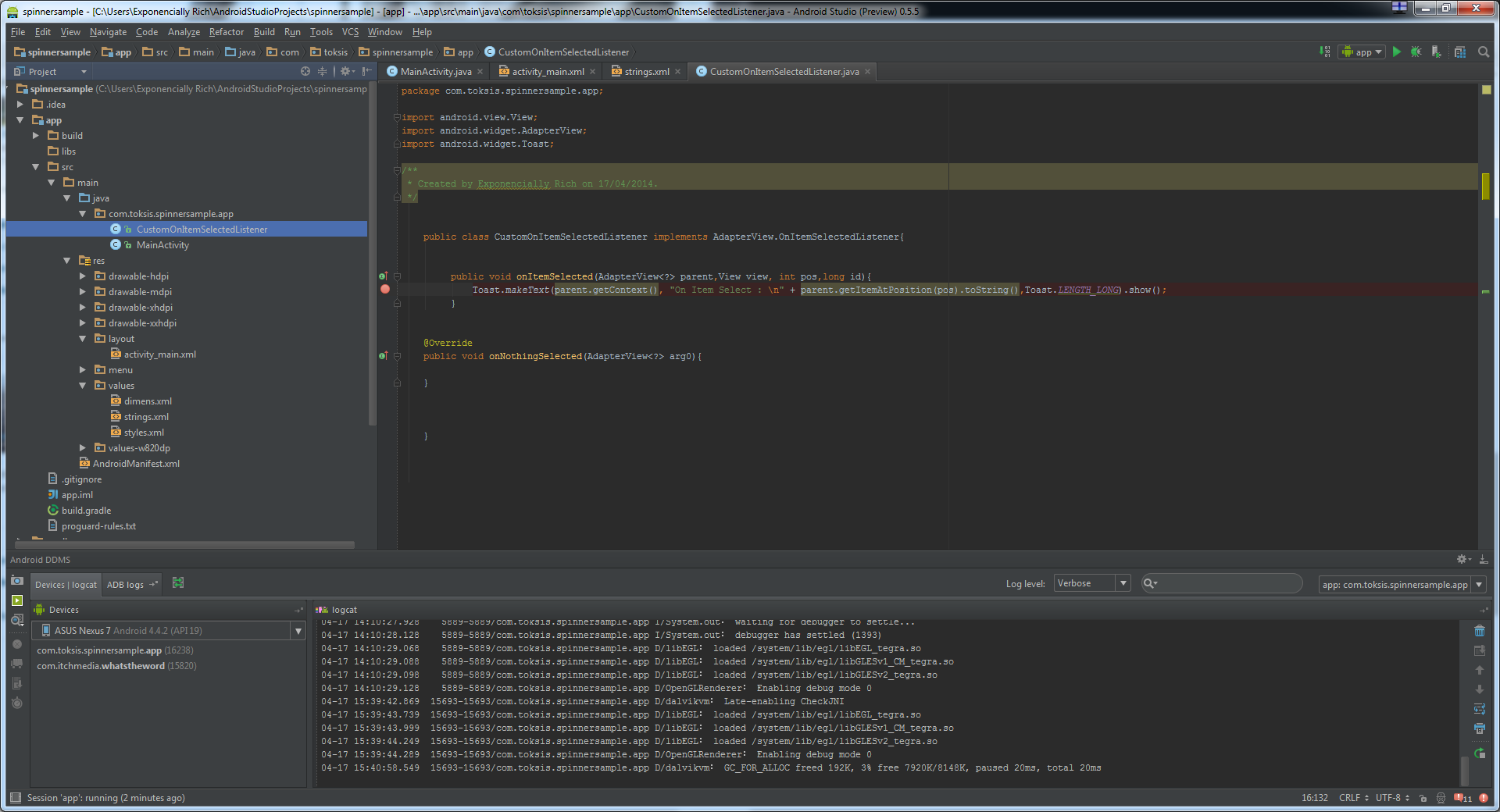

***Fig.1.1: Android Studio IDE which we will be using for development.***

* 1. **Motivation**

4-6 lines of a short story about how you got motivated to make the project. Sabko pata hai aisa kuch rehta toh nahi hai but feko jo mann mei aaye, motivation dikhna chahiye.

**CHAPTER 2. PROBLEM STATEMENT**

* 1. **PROBLEM STATEMENT**

4-5 lines explaining about what your project does or aims to do, don’t forget to add fancy words coz a great man once said “Haa, ye karlo pehle”.

* 1. **EXPLANATION**
* Bullet wise points mei pura page bhardo with explanation of the different modules of the project.
* Dekho, ye section ko tum Viva mei kya bologe uske liye practice ke tarah use kar sakte.
* Acche Acche words likho, Koi padhta toh nahi but kuch kiya hai iska satisfaction milega.
* Major Flex about your project – Line 1
* Major Flex about your project – Line 2
* Major Flex about your project – Line 3
* Major Flex about your project – Line 4
* Major Flex about your project – Line 5
* Conclusion about the explanation.

.

**CHAPTER 3. SOFTWARE REQUIREMENT SPECIFICATION**

* 1. **Software and Hardware Requirements**

Koi bhi 8k to 10k wale phone ke specs chipka do coz another great man once said “Inko Kya hi Pata Chalega”. Ek sample rakha hai niche , same to same bhi chipka doge toh “Mei likh ke deta hu, koi nahi dekhega”.

|  |  |
| --- | --- |
| RAM | 512 MB and above |
| Disk Space | 2.5 MB minimum |
| Processor Speed | 1 GHz and Above |
| Android Version | 4.1 and Above |

***Table .3.1: Software and Hardware Requirements for Project***

* 1. **E-R DIAGRAM**

The following diagram is the Entity Relationship Diagram for our Android App – <TITLE HERE>. The diagram represents the following schema:

Name (ID, ID2, ID3, ID4)

Name (ID, ID2, ID3, ID4)

Name (ID, ID2, ID3, ID4)

Name (ID, ID2, ID3, ID4)

Name (ID, ID2, ID3, ID4)

Name (ID, ID2, ID3, ID4)

Mere Project ka de raha hu reference ke liye, idhar tumhara ER daalo:

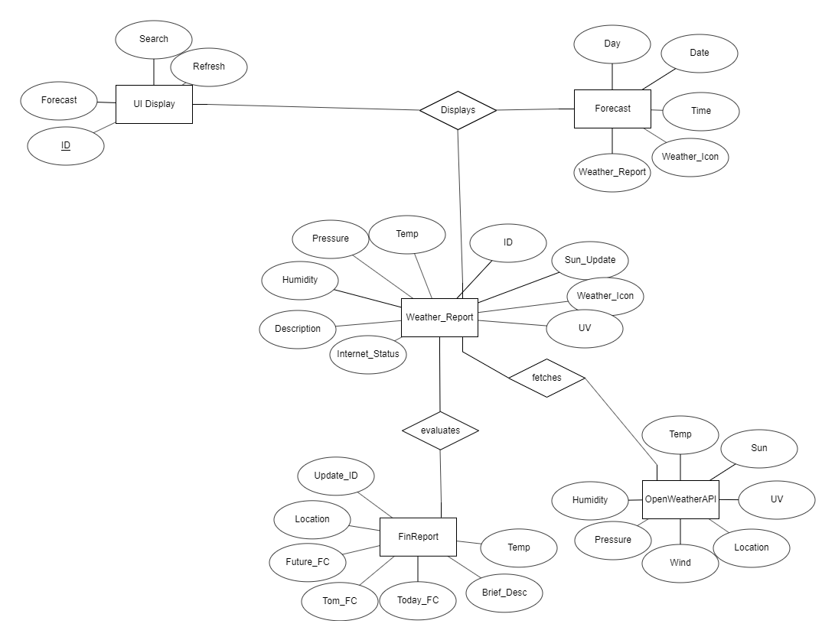

***Fig.3.1: Entity Relationship Diagram for Weather Forecasting System - Mausam***

**3.3 DATABASE CONNECTIVITY**

**<Yaha tumhare project ke DB Connectivity ka Info dedo, nahi hai DB toh delete, keeping my project ka content for reference>**

One of the major components of the App Development is the part of Database Connectivity as the database is required to store weather Information from OpenWeather before processing it for usage in Mausam. The OpenWeather API has the data in JSON format and a specimen of the schema is as below:

***Table 3.2 OpenWeatherMap Storage Format(Not the actual JSON but the Schema)***

|  |  |
| --- | --- |
| **Category** | **Value/Format** |
| Main | String, Single Word |
| Description | String, Sentence |
| Min_Temp | Integer, in Kelvin |
| Max_Temp | Integer, in Kelvin |
| Humidity | Integer, Range[0,100] |

So, after a brainstorming session, we decided that instead of converting JSON Documents into normal tables, we can use NoSQL Database Systems and after a common vote, we decided to use MongoDB connectivity in our project Mausam.

Thus, we have used MongoDB Java Connectivity in our App, Mausam . Since the Weather Data is already created and there is no use of Deleting the data , we perform only Read and Update Operations on the database. In other words, of all the CRUD Operations we perform only R and U Operations. The Database fetches the JSON Document from OpenWeatherAPI and stores it. Later using Java , we read the data from the database and also update the database with new data from OpenWeatherMap as per user needs.

**CHAPTER 4. IMPLEMENTATION OF PROJECT**

**4.1 MODULE DESCRIPTION**

**4.1 Module description:**

**4.1.1 Start page:**

3-4 lines of the first page/view which is shown after opening the application. But kaisa hai ki by the time tum idhar tak aaoge, mood jaega likhneka toh kuch bhi likh do.

**4.1.2 Second Page:**

**Likh do mast 7-8 line shayad main page ho ye tumhare app ka.**

**4.1.3 Third Page:**

Ye page bhi hai tumhare app mei?? Kaafi mehnat kiya lagta , thik hai likh do 7-8 lines jaise mann kare.

**4.1.4 About Page:**

Here, we have displayed our details as the developers of the application to detect plagiarism and also as a credit mechanism. (ye rehne do aise hi, app banaye ho, credit toh lege hi)

**4.2 SCREENSHOTS OF APP**

Apne app ke acche acche SS lelo coz SS lena toh roz ka kaam hai (also don’t judge my Screenshots, mei garib hu) :

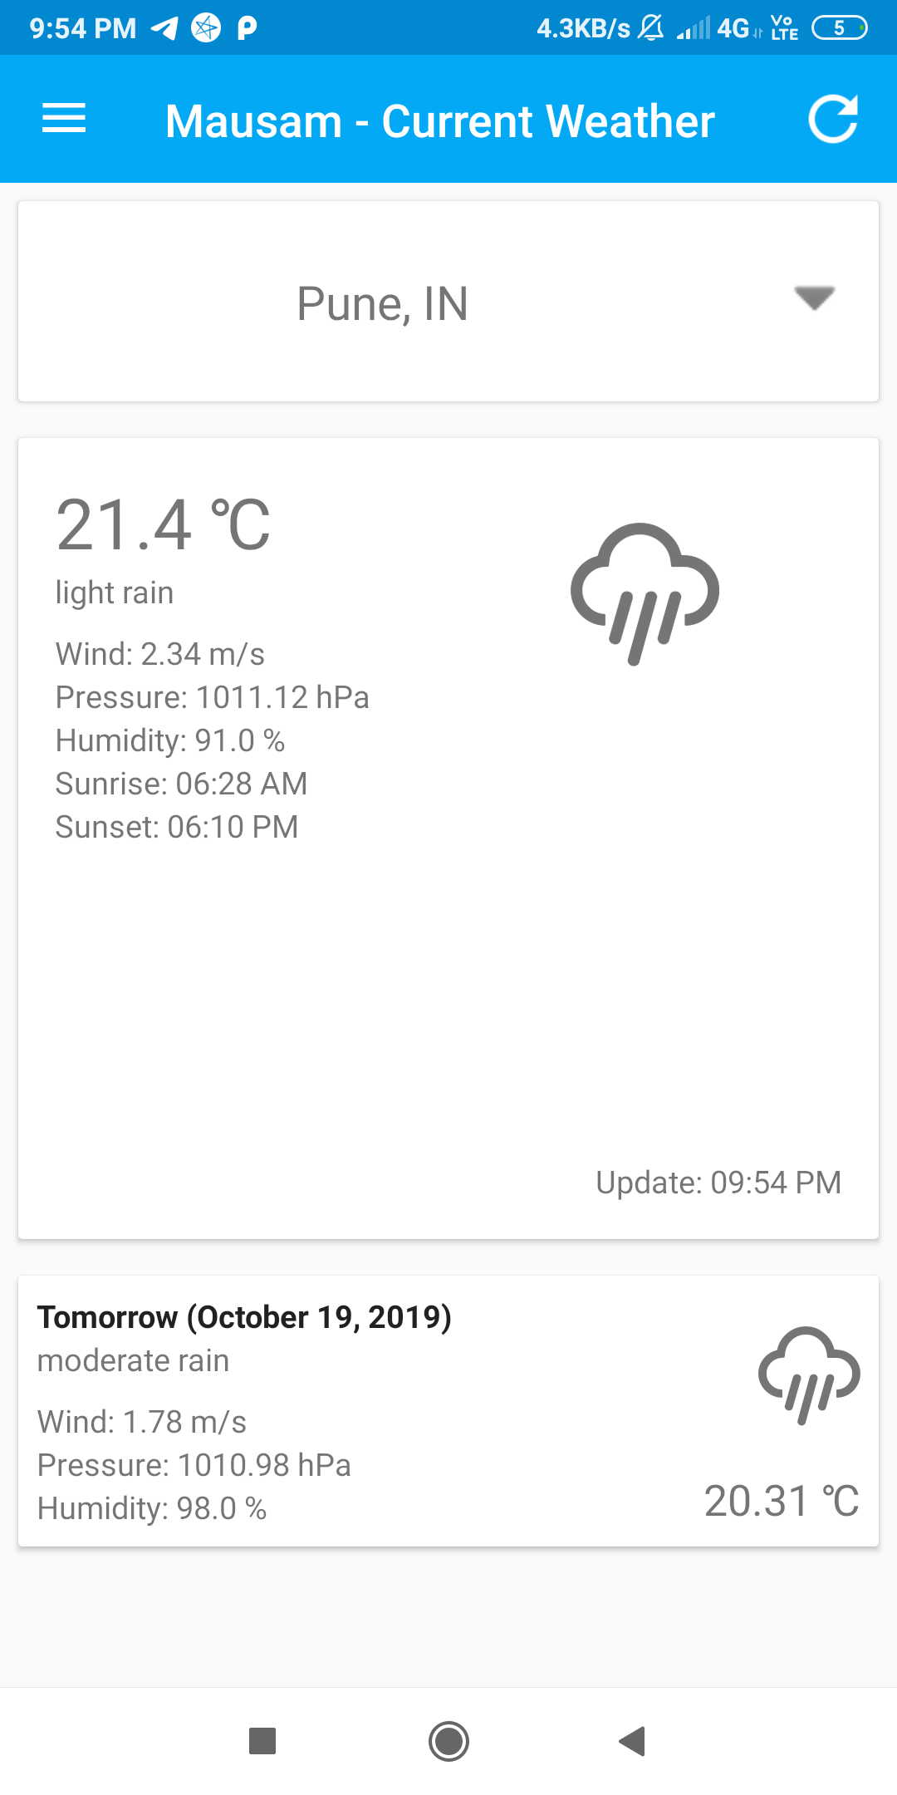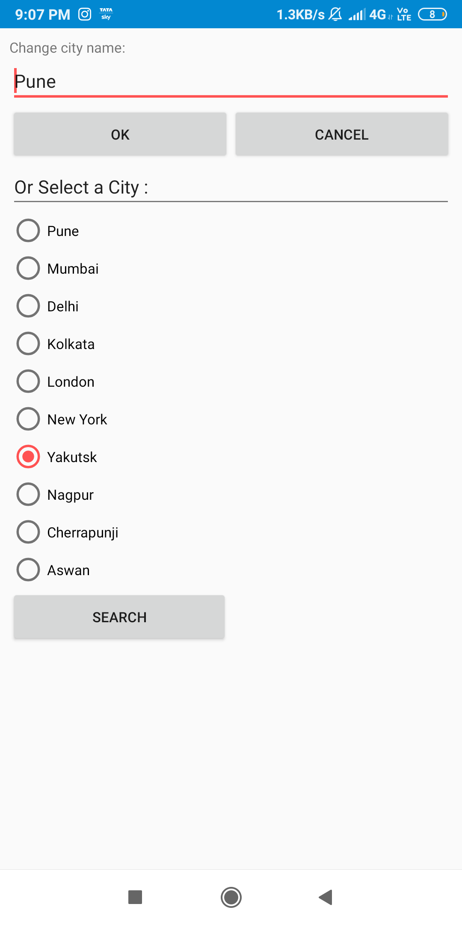

***Fig.4.2:*** ***SS kiska hai woh toh batana hi chahiye warna kisko kya samjega***

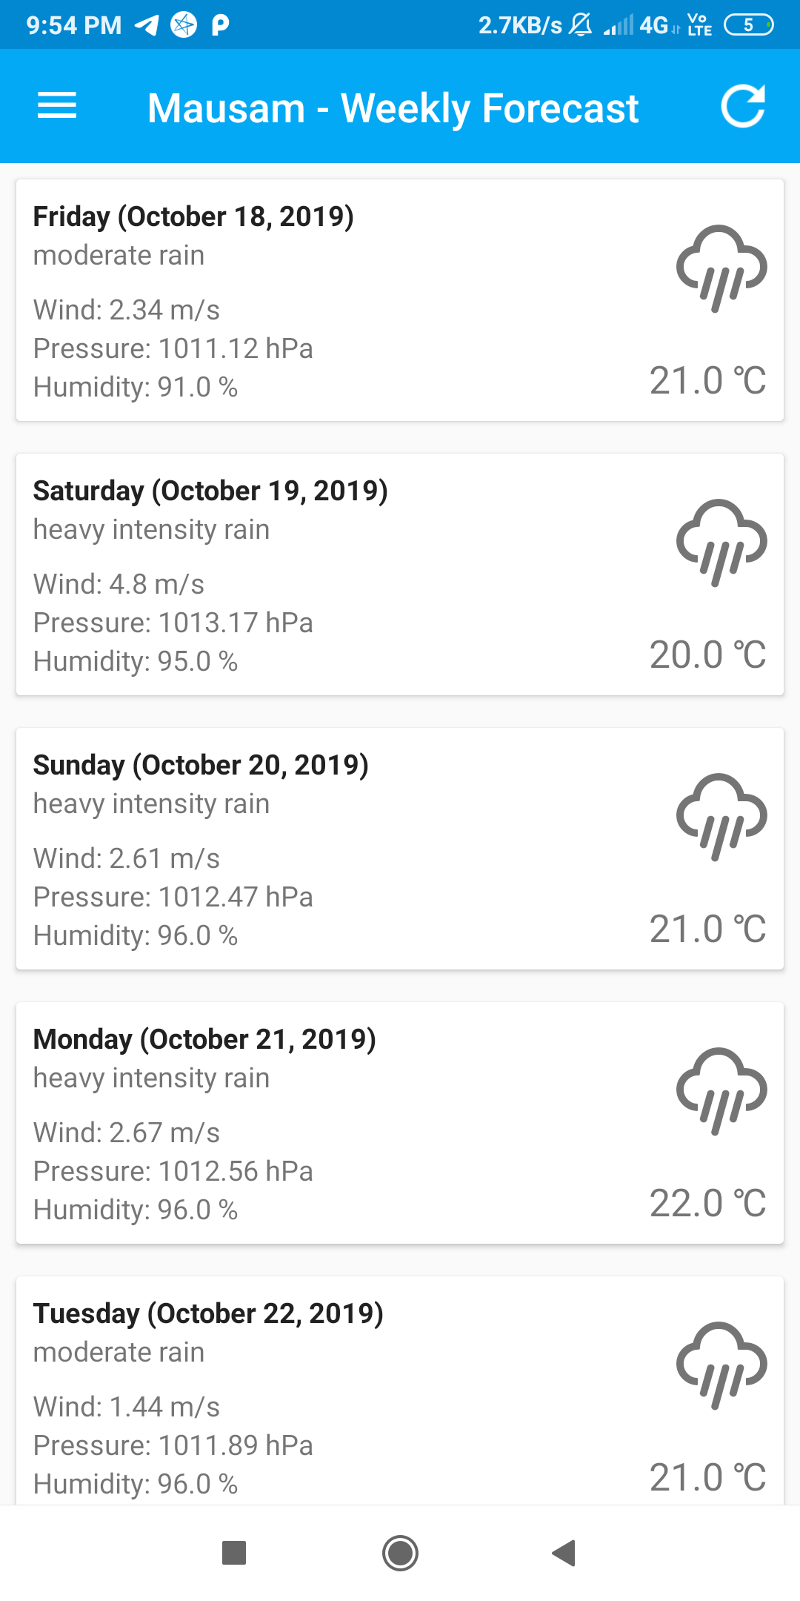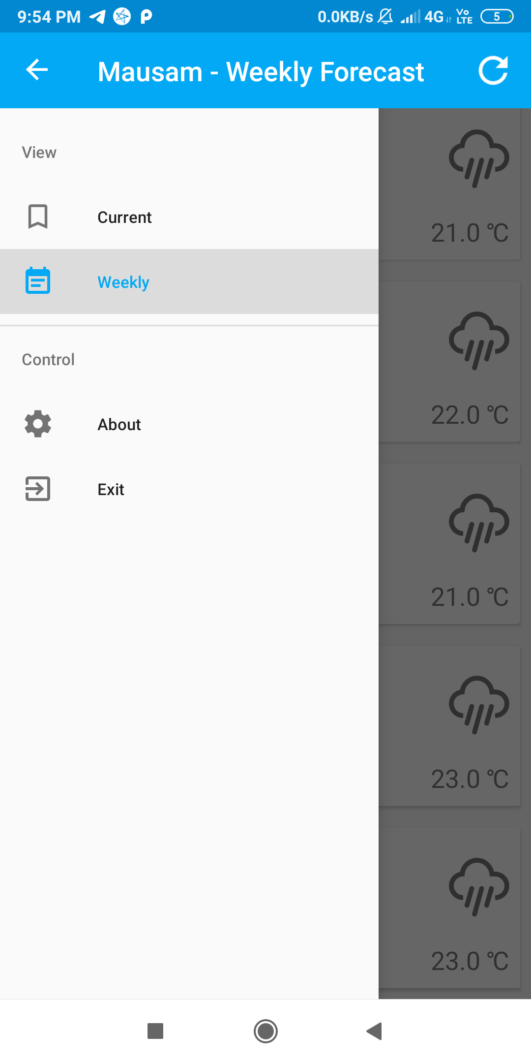

***Fig.4.2: XXXXXXXXXXXXXXXXXXXXXXXXXXXXXXXXXXXXXXXXXXXXXXXXXXXXXXXXXXXXXXXXX***

**CHAPTER 5. CONCLUSION**

Thus, we have successfully implemented PROJECT TITLE HERE as per our needs discussed in Motivation section and documented it for fulfillment of Skill Development Lab.